**ESS 132 Week 3 Discussion tasks**

i) Using the 2 maps below, draw in the Thiessen polygons and isohyets. You can do this on paper, or using powerpoint. If there is time, use the table on the second page to calculate the EUD for the Thiessen polygons and then calculate the EUR for the isohyets you have drawn. Please show your workings so I can offer feedback if you are going wrong somewhere!

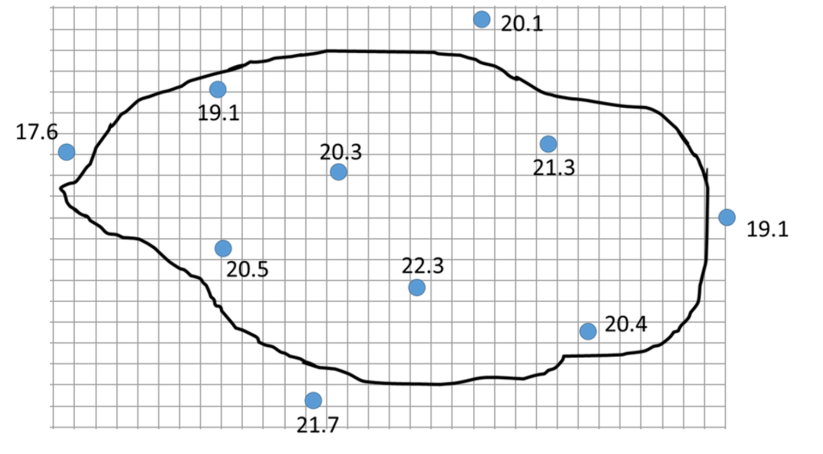



Table for Thiessen polygons



$$EUD=\frac{14 {km}^{2}×17.6 mm}{348 {km}^{2}}+\frac{37 {km}^{2}×19.1 mm}{348 {km}^{2}}+\frac{44 {km}^{2}×20.5 mm}{348 {km}^{2}}+\frac{12 {km}^{2}×21.7 mm}{348 {km}^{2}}+\frac{53 {km}^{2}×20.3 mm}{348 {km}^{2}}+\frac{13 {km}^{2}×20.1 mm}{348 {km}^{2}}+\frac{57 {km}^{2}×22.3 mm}{348 {km}^{2}}+\frac{56 {km}^{2}×21.3 mm}{348 {km}^{2}}+\frac{40 {km}^{2}×20.4 mm}{348 {km}^{2}}+\frac{22 {km}^{2}×19.1 mm}{348 {km}^{2}}$$

$$EUD=20.55 mm$$

Table for your isohyets

|  |  |  |  |  |  |  |
| --- | --- | --- | --- | --- | --- | --- |
| Isohyet | below 18 mm | 18-19 mm | 19-20 mm | 20-21 mm | 21-22 mm | above 22 mm |
| Area (km2) | 8 | 15 | 55+15 | 37+26 | 96 | 45 |

$$EUD=(\frac{8 {km}^{2}×18 mm}{297 {km}^{2}})+\left(\frac{15 {km}^{2}}{297 {km}^{2}}×\frac{18 mm+19 mm}{2}\right)+\left(\frac{55 {km}^{2}}{297 {km}^{2}}×\frac{19 mm+20 mm}{2}\right)+(\frac{15 {km}^{2}×20 mm}{297 {km}^{2}})+\left(\frac{37 {km}^{2}+26 {km}^{2}}{297 {km}^{2}}×\frac{20 mm+21 mm}{2}\right)+\left(\frac{96 {km}^{2}}{297 {km}^{2}}×\frac{21 mm+21 mm+22 mm}{3}\right)+(\frac{45 {km}^{2}×22 mm}{297 {km}^{2}})$$

$$EUD=20.62 mm$$